**Healthcare Data Analytics: Exploring NHS A&E trends with SQL queries and Power BI visualization.**

Ever wondered how long patients typically wait in hospital emergency departments across England? The NHS has introduced an operational standard in 2010, to establish a four-hour wait time target, mandates that at least 95% of patients attending A&E should be admitted, transferred, or discharged within four hours. This indicator examines instances of breaches of the four-hour A&E target since 2013. In this project, I analyzed real-world NHS A&E data from 2018 to 2025 at the provider level using SQL and created an interactive dashboard in Power BI. The aim was to identify trends, pinpoint underperforming hospitals, and understand the increasing demand on emergency services — all through data-driven insights.

**Data Source**

The data used in this project was sourced from the official NHS England statistics on A&E waiting times and activity. This dataset provides monthly and weekly figures ,including details such as total attendances, waiting times under and over 4 hours, emergency admissions, Number of patients spending greater than 4hour or 12 hour from from descision to admission.

You can access the dataset here

[NHS A&E Monthly Dataset](https://www.england.nhs.uk/statistics/statistical-work-areas/ae-waiting-times-and-activity/)

**Tools and Technologies used:**

* **Python**– To organize the collected data and connect it to SQL.
* **SQL (MySQL)** – For querying, cleaning, and aggregating hospital-level data
* **Power BI** – For building dynamic visualizations, KPIs, and dashboards
* **Excel** – For initial formatting and structural adjustments
* **GitHub** – To share and track progress

**Data Preparation and SQL Analysis**

**Step 1: Data Cleaning**

* Removed footnotes, merged cells, and empty rows, and null values



* Standardized column names and date formats
* Converted percentage values from string to decimal
* Resolved data type mismatches (e.g., double → int/float)

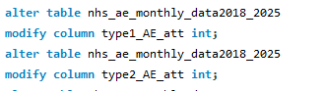

**SQL data base**

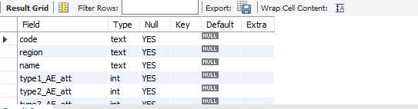

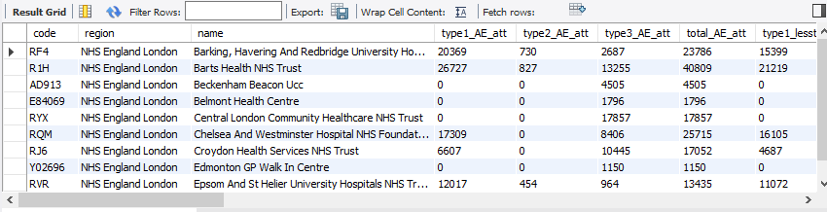

**Step 2: Complex Queries**

? Top 10 providers with highest total attendances over time

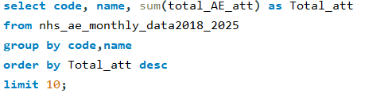

? Identify the worst month where >12 hr wait has highest per hospital

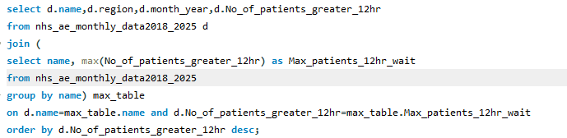

? Which hospital consistently failed to meet the 95% 4 hr target?

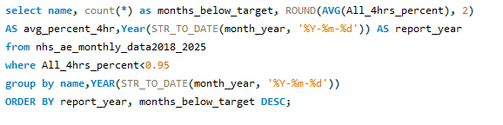

These queries helped extract actionable insights from a large and complex dataset.

**Integration with Power BI**

To effectively communicate the insights derived from SQL, the query outputs were **directly integrated with Power BI**. This allowed for:

* Real-time visualizations based on SQL data
* Interactive dashboards with filters and slicers
* Seamless updates and consistent data flow between SQL and Power BI

The combination of SQL and Power BI made it possible to both understand and **present the story behind the numbers** in a compelling and intuitive format.

To bring the numbers to life, I designed an interactive dashboard featuring:

**Key Visuals:**

* **KPI Card** showing % of patients seen within 4 hours
* **Line Chart** for trend analysis of percentage of attendance within 4 hours over time
* **Stacked Column Charts** comparing:
* Total attendances
* Patients seen in under vs. over 4 hours
* **Bar Chart** of Top 5 hospitals with the most A&E visits
* **Slicers** for filtering by month and provider

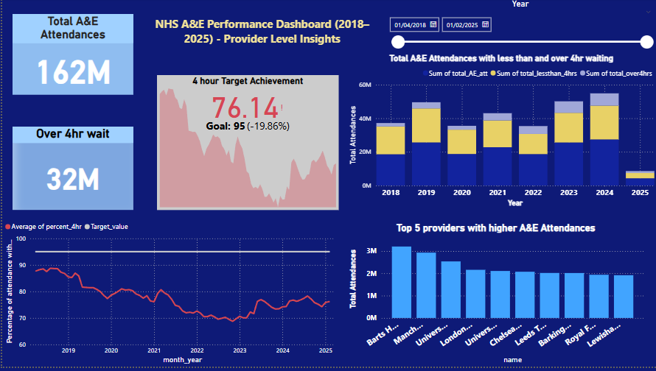

[Download the Power Bi Dashboard here](https://drive.google.com/uc?export=download&id=1NrY-NLqfSYqdNsaIz1ZKaGzZNe5dlS5P)

## Insights & Observations

* The **4-hour target** has been consistently missed by many providers since 2019.
* There is a **steady increase** in the number of patients waiting **more than 4 and 12 hours**, particularly noticeable during **2019–2020**. The performance dips correlate closely with COVID-19 peaks and peak demand periods.
* At the national level, the 95% standard has not been met on an annual basis since 2018, although it has been achieved in certain individual months by certain providers.
* Although the number of patients facing long waits has recently decreased, the overall average still remains below the 95% target, highlighting continued challenges in consistently meeting the standard.
* There has been an increase in A&E attendance, reflecting growing demand on emergency services.